**OPTIMIZATION AND ANALYSIS OF FLUIDIZED BED DRYER FOR IMPROVED THERMAL EFFICIENCY IN TEA FACTORIES**

**BONFACE OCHIENG OTEDO**

A Thesis Submitted to the Department of Mechanical and Industrial Engineering in Partial Fulfilment for the Requirements for the Award of the Degree of Master of Science in Industrial Engineering and Management of Masinde Muliro University of Science and Technology

**NOVEMBER, 2024**

DECLARATION

This thesis is my original work prepared with no other than the indicated sources and has not been presented for a degree or any award in any other university or any other institution

Signed……………………………………… Date……………………………

**Bonface Ochieng Otedo**

**SEI/G/01-70252/2021**

CERTIFICATION

We the undersigned certify that we have read and hereby recommend for acceptance by Masinde Muliro University of Science and Technology a thesis entitled, “**Optimization and Analysis of Fluidized Bed Dryer for Improved Thermal Efficiency in Tea Factories**”.

Signed…………………………………Date………………………………….

**Dr. Peter Cherop**

Department of Mechanical and Industrial Engineering

Masinde Muliro University of Science and Technology

Signed……………………………Date………………………………….

**Dr. Emmanuel E. Osore**

Department of Mechanical and Industrial Engineering

Masinde Muliro University of Science and Technology

COPYRIGHT

This thesis is a copyrighted material protected under the Copyright Act of 1999 and other international and national laws related to intellectual property. It cannot be reproduced in any way, either fully or partially, except for a brief extract for research, private study, scholarly review, or discourse with proper acknowledgment and written permission from the Directorate of Postgraduate Studies representing both the author and Masinde Muliro University of Science and Technology.

© Bonface Ochieng Otedo, 2024

DEDICATION

I dedicate this work to my family, so that it may be an inspiration and blessing not only to them but also to others around them. I thank them for their endless support and encouragement, God bless you all.

ACKNOWLEDGEMENTS

I want to express my gratitude and acknowledgement to my supervisors Dr. Peter Cherop and Dr. Emmanuel Osore, who made this research work feasible. I was able to complete this research proposal writing thanks to their direction and counsel. In addition, I want to thank the departmental defence team for making my defence great experience and for their insightful builds.

Special tanks also go to my dear wife Maureen Sengre and my family for their overwhelming support and prayers that carried me throughout the proposal writing period.

My gratitude also goes to my colleagues, Joseph Otieno, Reuben Tum, Conrad Mutobera, Sammy Kiragu, Griffin Pilot, Bennedeta Mbevi, Margaret Okoth, and Charity Wairimu for their valuable support and accouterment.

Lastly, I want to express my gratitude to the Almighty God for seeing me through the challenges of thesis writing.

ABSTRACT

Drying is a vital process in most agricultural industries to increase finished product shelf life and storage. This thesis focused on optimization of thermal energy consumption in black tea drying process using a fluidized bed dryer (FBD) in tea factories. The research also covered laboratory practical experiment and drying simulation using computational fluid dynamics (CFD). A quantitatively evaluation and examination of laboratory drying was done by means of computational fluid dynamics in ANYS Fluent. Tea drying input variables considered in the study were hot air temperature, velocity and time. Energy utilization (EU), energy utilization ratio (EUR), exergetic efficiency were investigated under the same dryer input parameters to determine the dryer’s performance. The response variables in the experiment were the black tea moisture content and thermal energy utilization. The velocity of hot air was varied between 0.21 m/s and 0.55 m/s while the dryer hot air temperature was varied between 70 °C and 130 °C. The drying time varied between 0 minute to 20 minutes. Box Behnken methodology under response surface design was used to design experimental models. The Resulting fifteen (15) experimental models guided in conducting black tea drying experiments in the macerated tea laboratory at Sotik Tea Company Limited using the miniature fluidized bed dryer Sherwood Tornado model 501. From the experiment results, it took 20 minutes to lower the dhool moisture content from 72 % to 3.5 %. The data obtained from the drying experiment was used to develop black tea drying curve and black tea drying rate. The Box Behnken design under response surface design methodology in Minitab software was used to analyse and optimize the black tea drying variables. The optimum variables were found to be hot air temperature of 100 °C, hot air velocity of 0.38 m/s and drying time of 12.9 minutes. The optimal drying variables above, resulted in a more acceptable moisture content in the final black tea of 3.5 % db which falls between the acceptable black tea moisture content of 3 % to 4 % . From the energy and exergy results, EU and EUR increased with increase of drying air temperature also EU and EUR decreased with increase of drying time. Similarly, exergy utilization decreased with increase in drying time likewise exergy loss increased by increasing drying air temperature.

TABLE OF CONTENTS

DECLARATION ii

CERTIFICATION ii

COPYRIGHT iii

DEDICATION iv

ACKNOWLEDGEMENTS v

ABSTRACT vi

TABLE OF CONTENTS vii

LIST OF FIGURES x

LIST OF TABLES xi

APPENDICES xii

LIST OF ABBREVIATIONS AND ACRONYMS xiii

LIST OF SYMBOLS xv

CHAPTER ONE 1

INTRODUCTION 1

1.1 Background 1

1.2 Statement of the Problem 6

1.3 Objectives 6

1.3.1 Main Research Objective 6

1.3.2 Specific Objectives 6

1.4 Research Questions 7

1.5 Justification 7

1.6 Significance of Study 7

1.7 Scope and Limitations 8

1.8 Conceptual Framework 8

CHAPTER TWO 9

LITERATURE REVIEW 9

2.1 Introduction 9

2.2 Energy Analysis 11

2.3 Exergy analysis 11

2.3.1 Geometry 14

2.3.2 Theoretical Section 14

2.3.3 Turbulent Modeling 16

CHAPTER THREE 21

MATERIALS AND METHODS 21

3.1 Materials 21

3.2 Methods 21

3.2.1 Experimental Design 21

3.2.1.1 Experimental procedure 21

3.2.2 Experimental Setup 21

3.3 Design of experiment 23

3.3.1 Experimental Models 24

3.4 Design analysis 24

3.4.1 Computational Fluid Dynamics 25

3.4.2 CFD Modeling 26

3.4.3 Geometry and Meshing 26

3.4.3.1 Mesh Independency Test 29

3.4.4 Boundary Conditions and Simulation Setup 30

3.4.5 Fluidization Condition 32

CHAPTER FOUR 34

RESULTS AND DISCUSSION 34

4.1 Drying Experimental Results 34

4.1.1 Drying Curve 34

4.1.2 Rate of Drying Curve 35

4.2 Results of Experimental Runs 36

4.3 Model Summary 36

4.3.1 Analysis of Variance 37

4.3.2 Regression Equation 38

4.3.3 Modified Regression Equation 38

4.4 Optimization of Process Variables 38

4.5 Surface and Contour Plots 39

4.6 Energy and Exergy Analysis 41

4.6.1 Energy Analysis 41

4.6.2 Exergy Analysis 45

4.7 Simulation results 47

4.7.1 Dhool Fluidization Analysis 47

4.7.2 Drying Air Velocity Analysis 49

CHAPTER FIVE 51

CONCLUSIONS AND RECOMMENDATIONS 51

5.1 Conclusion 51

5.2 Recommendation 51

REFERENCES 52

APPENDICES 55

LIST OF FIGURES

Figure 1.1: Tea Processing Flow Chart 1

Figure 1.2: Typical Fluidized Bed Dryer 4

Figure 1.3: Relationship between Tea Drying Rate and Moisture Content 5

Figure 1.4: Conceptual Framework 8

Figure 3.1: Sherwood Tornado 501 Dryer Representation Diagram 23

Figure 3.2: Computational Fluid Dynamics Simulation Process 25

Figure 3.3: 2D Dimensional FBD Geometry 27

Figure 3.4: Mesh Structure of the Model FBD 28

Figure 3.5: Dhool Bed Height Patching 33

Figure 4.1: Relationship between Moisture Content and Drying Time 35

Figure 4.2: Relationship between Drying Rate and Moisture Content 35

Figure 4.3: Optimal Drying Process Variables 39

Figure 4.4: Surface Plot of Moisture Content vs Velocity and Temperature 40

Figure 4.5: Contour Plot of Moisture Content vs Velocity and Temperature 41

Figure 4.6: Relationship Between Energy Utilization and Drying time 43

Figure 4.7: Effect of Energy Utilization at Different Temperature Ranges 43

Figure 4.8: Variation of Energy Utilization Ratio with Drying Time 44

Figure 4.9: Variation of Energy Utilization Ratio with Air Temperature 45

Figure 4.10: Variation of Exergy Inflow with Temperature 45

Figure 4.11: Variation of Exergy Utilization with Drying Time 46

Figure 4.12: Variation of Exergy at the outlet with Drying Time 46

Figure 4.13: Variation of Exergy Efficiency with Drying Time 47

Figure 4.14: Initial Volume Fraction of Dhool 48

Figure 4.15: Volume Fraction of Dhool at 2 seconds 48

Figure 4.16: Volume Fraction of Dhool at 10 seconds 49

Figure 4.17: Velocity Contour at Fluidization Stage 50

LIST OF TABLES

Table 2.1: Literature Review Summary 19

Table 3.1: Levels and Factors in the Experiment 23

Table 3.2: Design of Experiment 24

Table 3.3: ANSYS Meshing 29

Table 3.4: Mesh Independency Review 30

Table 3.5: Model Boundary Conditions 31

Table 3.6: ANSYS Solver Setup Conditions 31

Table 4.1: Moisture Content at Various Drying Times 34

Table 4.2: Resultant Moisture Content at Different Drying Conditions 36

Table 4.3: Summary of Statistical Parameters 37

Table 4.4: Analysis of Variance 37

Table 4.5: Input and Output Temperatures 41

Table 4.6: Results on Energy Utilization 42

APPENDICES

Appendix 1: Sherwood 501 fluidized bed dryer 55

Appendix 2: Kern EM weighing scale 56

LIST OF ABBREVIATIONS AND ACRONYMS

a Air

A Area (m2)

CFD Computational Fluid Dynamics

Cp Specific Heat (J/kg s)

CTC Cut Tear and Curl

da Drying Air

dc Drying Chamber

DM Dry Mass

eff Efficiency

EU Energy Utilization (kJ/s)

EUR Energy Utilization ratio

Ex Exergy (kJ/s)

Exeff Exergy efficiency

FBD Fluidized Bed Dryer

FBDs Fluidized Bed Dryers

h Enthalpy (kJ/kg)

hfg Latent Heat of Vaporization of Water (kJ/kg)

ht Heater Temperature

i Inlet

Jj Species Diffusion Flux, mol/m2.s

Jw Water Mass Flux

Keff Effective Conductivity, W/m.K

L Loss

m Mass Flow Rate (kg/s)

MT Made Tea

o Outlet

Qevap Evaporation Heat Transfer Rate (kJ/s)

R2 Coefficient of Determination

RSM Response Surface Methodology

T Temperature (0C)

Tref Ambient

U Overall Heat Transfer Coefficient (W/m2 .K)

umf Least Fluidization Air Velocity

V Air Velocity (m/s)

W Weight of dry black tea (kg)

W Weight of wet dhool (kg)

Wd Weight of dry dhool

Ww Weight of wet dhool

X Moisture Content

LIST OF SYMBOLS

ρ Density (kg/m3)

ρg Gravitational Body Force, kg m/s2

ω Humidity Ratio (kg/kg dry matter

CHAPTER ONE

INTRODUCTION

# Introduction

## Background

Tea statistics has shown that tea is produced mostly in Asia (India, China, Vietnam, Sri Lanka and Indonesia). In Africa tea is produced in the tropical regions (Kenya, Zambia, Tanzania, Malawi and Uganda). Tea is also produced in South America with Brazil and Argentina being the major producers. Of all these, Kenya, China, Sri Lanka and India are the major producers and their production accounts to 77 % globally. The leading producer of tea worldwide is China while Kenya leads tea export worldwide. Tea contains elements that acts as antimicrobials which have good inhibitory and bactericidal. Polyphenols (catechins) in tea acts as antioxidants (Deb and Jolvis Pou, 2016). Figure 1.1 shows a tea processing flow chart.

Shoot

Withering

Rotor vane

CTC

Oxidation

Black Tea

Witheringg

Rolling/maceration

Drying

Drying

Witheringg

Rotor vane

Oxidation

Drying

Oolong

CTC

Green Tea

Withering

Rolling

Oxidation

Drying

Orthodox

**Figure 1.1: Tea Processing Flow Chart**

Tea is commonly processed in four categories: Oolong tea, green tea, Orthodox tea and black tea (semi fermented, non-fermented and completely fermented). Black tea accounts to 78 % of the total tea produced globally. Black tea is stronger in flavour than other forms of teas (Deb and Jolvis Pou, 2016).

Drying is the mostly used method in food preservation. Vegetables, grains and fruits with high moisture content are regarded as perishable (Kaleta et al., 2013). Thus, drying method is inevitable in domestic and industrial processes for food preservation. Research has revealed that industrial dryers can consume energy equal to 12 % of the total energy produced in the industrial plants. Consequently, the costs of the drying process can therefore reach between 60-70 % of the total cost of production (Sarker et al., 2015; Smith, 2008). Thus, this has pointed an opportunity for drying process optimization for reduced energy consumption as quality products are produced for consumption.

Various drying techniques are used in Industrial drying processes namely, fluidized bed, endless chain dryer, convective, microwave, solar, infrared and spray drying. Out of all these types of dryers, fluidized bed dryers have proved to have the highest efficiency in regard to thermal energy, hence, suitable for most industrial applications (Meziane, 2011).

Fluidized bed dryers have several advantages and these include: Increased contact surface area between granules and hot drying air, greater transfer of heat and mass, improved drying volume since there is higher fraction of particle mass to mass of drying air, drying air temperature uniformly distributed and can handle products with massive moisture content (Izadifar and Mowla, 2003). Fluidized bed dryers also have low maintenance costs since they have no moving parts (Antony and Shyamkumar, 2016). Fluidized bed dryers give better heat and mass transfer hence reducing the product drying time without depleting the nutritional value of the product (Cheevitsopon and Noomhorm, 2011; Mujumdar, 2006).

Fluidized bed dryers are used in most tea factories, for black tea production. Macerated tea leaves commonly known as dhool on the dryer bed are blown by hot drying air through the perforated bed to expand dhool drying area. Drying air also increases heat and mass transfer and rate of vapour diffusion. Dhool fluidization is achieved when the velocity of hot air is more than the least fluidization air velocity umf. At this fluidization velocity, dhool is lifted at a height (float) hence, fluidized. Fluidization start point is obtained from least fluidization velocity. Increasing hot drying air further above the minimum fluidization velocity forces hot air to pass through the dhool porosity zone as air bubbles. Determination of the right velocity of drying air inside fluidized bed dryers has resulted in reduced thermal energy consumption in most tea factories (Yohana et al. 2018). This research focused on the determination of the optimal tea drying variables to maximize usage of the available thermal energy.

Exergy, in a drying process, is the extreme useful work by the dryer. Exergy exit from the drying space is normally less compared to exergy infeed to the drying chamber since much exergy is used in irreversibility (Mugi and Chandramohan, 2021). Exergy analysis is the most crucial tool for systems design, redesign, analysis and thermal systems optimization as it gives quality energy, magnitudes of losses and effects of the surrounding variables. Previous research works on heat transfer using experimental conditions of inlet hot air flow rate, velocity and humidity as a dispersion fluid were conducted through air bubbling. Many experimental investigations regarding heat and mass conveyance investigation of particles using fluidized bed dryers (FBDs) have been done. However, limited studies have been done on exergy and energy of dhool drying in fluidized bed dryers (Sarker et al., 2015; Smith, 2008)**.** Therefore, deliberate attention towards improvement of thermal efficiency in tea factories’ Fluidized bed dryers is justified. Figure 1.2 shows a typical fluidized bed dryer.

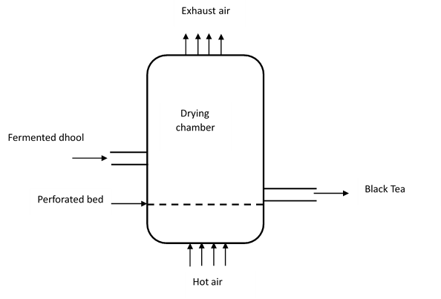

Figure 1.2: Typical Fluidized Bed Dryer

Fermented dhool is fed to the FBD where the drying (firing) process begins. Black tea quality features are prompted by the drying process variables including hot air flow rate, hot air temperature, height or loading rate and drying time. Drying temperature is a key parameter in tea drying. When tea is exposed to too high temperatures it results to tea hardening whereas when tea is exposed to very low temperatures it will result to skewed tea particles. Past experiments have revealed that tea exposed to temperature range of 90 – 140 °C is acceptable in terms of quality parameters. The air flow rate to the dryer depends on the dhool moisture content and drying air temperature. Air stream depends on the blower rated speed, inlet duct diameter, exhaust duct diameter, pressure gradient and the damper position. Drying capacity of the dryer is improved with increasing the air flow rate. Extreme surge of air flow blows tea particles away (Deb and Jolvis Pou, 2016).

Bed thickness (dryer loading) need to be maintained properly. Dryer with less loading results to porous bed hence, hot drying air will escape through it. On the other hand, very thick loading or packed bed leads to improper contact of hot air with tea hence, producing uneven tea. All these drying process variables depend on each other thus, should be accordingly optimized to improve the thermal efficiency of the fluidized bed dryer (Tea research association 2017). Hence, the objective of this research study, is to carry out energy and exergy investigation for optimization of drying process variables to improve the thermal effectiveness on the FBD in tea factories.

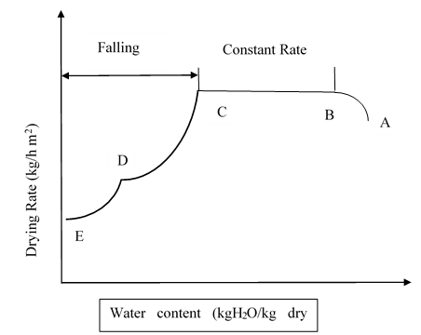

Figure 1.3: Relationship between Tea Drying Rate and Moisture Content

In order to study, analyse and solve sophisticated engineering problems on heat and mass transfer, and flow of fluid, Computational Fluid Dynamics (CFD) techniques are used (Jamaleddine and Ray, 2010). Computational fluid dynamics uses computers and applied mathematics in simulation of fluid flow states so that it helps in design and process optimization (Kuriakose and Anandharamakrishnan, 2010). Research has revealed that CFD is a very helpful tool to foresee fluid particle drift configuration i.e., velocity, time residency and impact position (Kuriakose and Anandharamakrishnan, 2010). This work focused on improving the effectiveness of the drying process of black tea in tea factories using CFD simulation method, ANSYS version 2022 R1.

## Statement of the Problem

The present productivity and thermal energy key performance indicators in the fluidized bed dryers show that the dryer operates at 1.03 kg of made tea (MT) per kg of firewood used against a target of 1.5 kg MT per kg firewood. This leads to less made tea being delivered by approximately 0.4 kg made tea per one kilogram of firewood used. On the other hand, the current thermal energy consumption of 17 MJ/kg made tea against a target of 15 MJ/kg made tea leads to over consumption of thermal energy by 2 MJ per a kg of made produced. This energy consumption indicates that either there is excess energy consumed due to over drying of tea or as a result of release of unutilized energy to the environment through the exhaust line. Therefore, there is need to enhance the fluidized bed dryer process variable to increase the thermal efficiency, reduce volume of biomass consumed at the boiler, reduce hot emission of particulate matters to the environment through the boiler chimney, and eventually reduce the cost of operation.

## Objectives

### Main Research Objective

To optimize black tea drying variables in fluidized bed dryers for improved thermal energy.

### Specific Objectives

1. To optimize drying process variables for minimal moisture content
2. To determine the effects of process variables on exergy and energy efficiencies
3. To develop a black tea drying curve.

## Research Questions

1. What are the optimal process variables in the black tea drying process?
2. What are the effects of process variables on dryer thermal energy?
3. Can the black tea drying curve be determined?

## Justification

Studies have revealed that industrial drying processes can consume around 12 % of the total thermal energy generated in the industrial set up. The operating cost due to the drying process consequently, can reach up to 70 % of the whole production cost in manufacturing plants (Das et al., 2021; Sarker et al., 2015). In most tea factories, biomass boilers are used to produce steam for process consumption. In this regard, firewood is used for firing the boilers. Due to high steam demand to meet the dryer’s operation, firewood is used in excess to generate steam at the biomass boilers. This results in deforestation which goes contrary to agenda 2030 for sustainable development that requires “to take urgent action to address the climate change and protect the planet from degradation so that it can support the requirements of the present and the future through sustainable production and consumption” (UN agenda 2030, 2015). By improving the thermal efficiency of FBDs, tea factories will increase the business profit margin, reduce environmental impacts, become competitive in the global markets and, improved FBD reliability. Therefore, the need to optimize FBDs operating variables for reduced thermal energy consumption is justified.

## Significance of Study

Drying is inevitable in black tea processing plants since it increases the shelve life of the produced black tea. The drying process has been found to consume a larger amount of thermal energy produced in industrial plants. Higher thermal energy consumption increases plant operating costs. This study analysed the FBD working variables using experiments and CFD to obtain optimal FBD variables for improved thermal efficiency. The study adds more knowledge on fluidized bed dryers. The data obtained from this research is key for the future of fluidized bed dryers’ production and optimizing for other products such as pharmaceuticals, chilli, rice, carrots and wheat.

## Scope and Limitations

The research scope was limited to black tea drying process in Sotik tea factory. Fully fermented dhool was used as specimen for the drying process in a fluidized bed dryer. The drying variables were analysed using Box Behnken methodology under response surface methodology. The study involved the use of computational fluid dynamics in ANSYS fluent software to leverage on the laboratory experimental results.

## Conceptual Framework

Figure 1.4 shows the conceptual framework for the study.

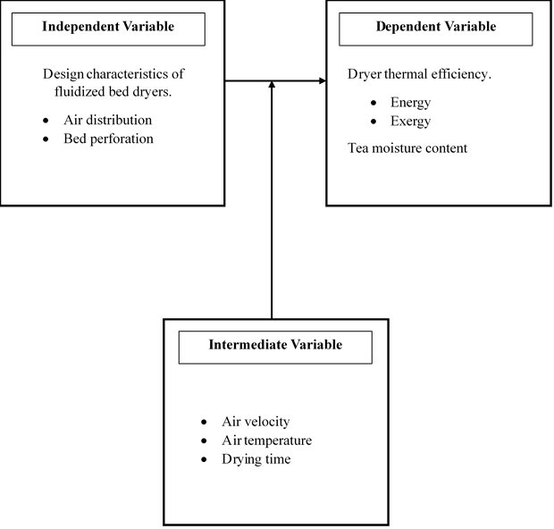

Figure 1.4: Conceptual Framework

CHAPTER TWO

LITERATURE REVIEW

# Literature Review

## Introduction

Tea is the most consumed beverage globally (Lang’at et al., 2016). Tea has great medicinal value which include, nitrosamine formation inhibition, cancer prevention and reduction of tumor growth. Catechin in tea acts as scavenger of reactive oxygen, thereby limiting cholesterol in blood streams resulting in reduction of coronary heart disease. Tea also acts as an antioxidant in human body. Due to green tea medicinal values, it has outweighed other types of tea in terms of consumption in Japan and China. Global annual tea production is estimated to be around 6.1 million tons. The projected growth in tea production by the year 2025 is 14.7 %, which is about 6.9 million tons. Green tea and black tea production increased globally in 2013 by 5.1 % and 5.4 % respectively (World tea production and trade, 2015). Drying is the process of moisture removal from Cut Tear and Curl (CTC) tea to about 3 % to 4 % in order to increase the shelve life of tea leaves. FBD was used in the drying process due to its ability to dry products with very low moisture contents while delivering very high efficiencies. This research work’s objective was to optimize the fluidized bed dryer operating variables and analyse the performance based on the energy consumption.

The analysis of energy consumption in the dryer was done using the fabricated prototype. The first test was done to establish the effects of air flow on the moisture levels under a temperature of 80 °C and a drum speed of 12.56 rad/s. Results revealed that at low speed, most heat concentration was on the heating source and very little conveyed to the drying chamber. On the flip side, an increase in hot air velocity caused FBD bed turbulence, hence sufficient drying. Very high velocity resulted in particle cooling during drying thus slowing the drying rate. In the experiment, it was concluded that the drying resident time is inversely proportional to the drying rate. The second experiment was to establish the relationship between the drum speed and the moisture content. The condition of test was set at 0.167 m3/s and 80 °C. It was observed that at low drum speed, the drying rate was enhanced. It was also observed the bottom layer of the drum dried faster than the top layer. With increased drum speed, the drying rate was increased. The third experiment was to study the temperature variation with respect to moisture. The experiment was carried out at 12.56 rad/s drum speed and 0.167m3/s hot air velocity. It was observed that higher evaporation rate occurred between 40 tand 80 °C (constant rate). At this stage, sensible heat was transferred to the tea to enhance falling rate stage of green tea drying. Temperatures of between 80 °C and 100 °C resulted in the acceptable green tea moisture content of between 2 % to 5 % (Lang’at et al. (2016).

The evaporation rate is obtained using Equation 1 (Lang’at et al., 2016).

$Evaporation Rate, ER=\frac{Evaporated moisture (kg)}{Drying chamber area \left(m^{2}\right)x drying time (s)}$ (1)

According to Sarker et al. (2015), in his research paper on energy and exergy study of industrial fluidized bed dryer of paddy, drying is an energy rigorous operation. 12 % of the energy used in the industrial process is consumed by the industrial dryers. The drying cost can range between 60 %-70 % of the total production cost (Sarker et al., 2015). To achieve sustainable development, energy is an important factor (Vera and Langlois, 2007). Therefore, it is prudent to maximize the dryer energy efficiency. Drying in FBD can be done in two ways; (i) batch wise where the FBD is charged with the wet product to be dried and once the product attains the anticipated moisture content, it is discharged from the dryer. (ii) Continuous process where wet product is fed into the FBD continuously as the dry product is also discharged continuously from the FBD. To determine the FBD energy relations and thermodynamic behaviors of hot drying air in the drying chamber, exergy and energy analysis is inevitable (Chowdhury et al., 2011). Exergy analysis is a tool used to provide optimal drying parameters by determining the possibility to design a more efficient thermal system. Studies on exergy have revealed that, low exergy efficiencies have led to environmental impacts (Rosen and Dincer, 1997).

## Energy Analysis

Energy utilization (EU) in a fluidized bed dryer is computed according to Equation 2.

$EU= m_{da}(h_{dai}-h_{dao})$ (2)

The drying air enthalpy is determined according to Equation 3.

$h=C_{pda}(T-T_{ref})+h_{fg }w$ (3)

Heat transfer rate as a result of moisture evaporation inside the dryer during drying process is determined according to Equation 4.

$Q_{evap}=mwh_{fg}$ (4)

The energy utilization ratio (EUR) of the dryer is determined according to Equation 5.

$EUR= \frac{m_{da}(h_{dai}-h_{dao})}{m_{da}. C_{pda}(T_{hto}-T_{hti})}$ (5)

## Exergy analysis

The overall exergy in, out and wastes in the dryer is determined from second law thermodynamics. Exergy analysis procedure for drying chamber is calculated at steady intervals to determine rational for exergy deviation of the drying process.

Exergy flow values are calculated using the characteristics of the working drying air from the first law of energy balance. In this regard, the equation of general form of applicable exergy is used (Sarker et al., 2015).

$Ex= m_{da}.C_{pda}\left\{\left(T-T_{ref}\right)-\left(T_{ref}InT/{T_{ref}}\right)\right\}$ (6)

The exergy at infeed and exit of the drying chamber can be determined depending on their respective temperatures.

The Exergy at the drying chamber inlet is determined according to Equation 7.

${Ex}_{dci}=m_{da}C_{pda}\left\{{(T}_{dci}{-T}_{ref}\right)-\left(T_{ref}In{T_{dci}}/{T_{ref}}\right)\}$ (7)

The Exergy at the drying chamber outlet or exhaust is determined according to Equation 8.

${Ex}_{dci}=m_{da}C_{pda} \left\{{(T}_{dco}{-T}_{ref}\right)-\left(T_{ref}In{T_{dco}}/{T_{ref}}\right) \}$ (8)

The Exergy loss (Exloss) is given by Equations 9 and 10.

${Ex}_{loss}= {Ex}_{dci}-{Ex}_{dco}$ (9)

${Ex}_{loss}=\left( 1- \frac{T_{ref}}{T_{s}}\right)Q_{thermal}$ (10)

but

$Q_{thermal}=U.A_{d }\{ \left(\frac{T_{dai}+ T_{dao}}{2}\right)-T_{ref}\}$ (11)

Therefore, exergy evolved due to mass transfer of evaporated humidity was given by the Equation 12.

${Ex}_{evap}=(1-\frac{T_{ref}}{T_{evap}})Q_{evap}$ (12)

The Exergy efficiency, Exeff is determined according to Equations 13 and 14.

${Ex}_{eff}= \frac{{Ex}_{dci}-{Ex}_{loss}}{{Ex}_{dci}}$ (13)

${Ex}_{eff}=1-\frac{{Ex}_{loss}}{{Ex}_{dci}}$ (14)

Energy usage ratio and energy usage at the initial drying stage of paddy, Exergy efficiency reduce with increased air temperature range between 103 °C -113 °C. Exergy balance analysis revealed that 31 % - 37 % exergy is used in paddy drying hence, opportunity to explore utilization of the remaining exergy. Exergy utilization can be achieved through sufficient lagging on the drying chamber wall or by recycling the exhaust hot air.

Nazghelichi et al. (2013) conducted research on CFD simulation and optimization of factors affecting the performance of a fluidized bed dryer. As a result, a fluidized bed dryer was simulated using CFD techniques in this study, and the main emphasis of the work was on optimizing system-affecting factors such as air velocity, bed depth, particle size, and drying air temperature using Taguchi methodology. Carrot cubes were used for this study. Carrot contains high sugar levels (Sumnu et al., 2005) and have significant concentrations of vitamins and minerals i.e., B1, B2, B6 and B12. Carrots can be eaten raw, cooked or dried to make quick soup. Dried carrot slices are a great contender for creating an oil free snack meal (Sumnu et al., 2005). Drying is a considered process for fruits and vegetables preservation and storage to increase their shelf life (Kaya et al., 2009). FBDs are broadly used in the drying of particle food since they guarantee high intensities of heat and mass transfer together with high drying rates and good quality of dried foodstuffs (Białobrzewski et al., 2008).

Latent heat of evaporation and the comparatively low energy efficiency of industrial drying process need energy input in practical applications (Syahrul et al., 2002). The operation cost for dryers are much higher than the original capital cost.Therefore, innovative drying techniques and dryer designs are inevitable to optimize energy utilization (Mujumdar, 2006). Various process optimizations have own characteristics. Genichi Taguchi developed Taguchi technique with analysis of variance (ANOVA) as a statistical tool to enhance the quality of produced products. Calculating the temperature quantities and its distribution inside the FBD is critical for achieving design objectives as well as determining energy and exergy efficiencies. It can be challenging or even difficult to precisely crack an object in flow’s equations due to the complication the fluid dynamics problems (Mousavi et al., 2009). In the field of computational fluid dynamics (CFD). Fluid flow related issues are solved and analyzed using numerical techniques and algorithms. The calculations required to simulate how liquids and gases interact with surfaces determined by boundary conditions are done by computers. A rapid developing CFD technique can be used to reduce the time needed to produce a product, reduce energy consumption, improve existing processes and design new ones (Jafari et al., 2008). Food process optimization studies has been done. However, little effort has been put on Taguchi technique-based CFD simulation and optimization of fluidized bed drying parameters. The effects of energy utilization, particle sizes and bed height is not fully understood. Therefore, in this study, a fluidized bed dryer was simulated using CFD techniques with main emphasis being optimizing system-affecting factors such as particle size, bed depth, and drying air temperature using Taguchi methodology (Jafari et al., 2008).

### Geometry

Cylindrical geometry developed using Gambit 2.3.16 software. Drying column was then simulated using ANSYS software. Proportional cylinder was produced in this work as drying chamber to safe on computational time and cost. was used to generate geometry grids.

### Theoretical Section

The leading equations in heat and mass transfer flow, conservation of energy and turbulent models (Mu’im Abdul Nasira et al., 2021).

Mass conservation (continuity) equation is:

$\frac{∂p}{∂t}+∇.p\left(V\right)=0$ (15)

where time (t), density(ρ), divergence (Δ) and velocity (υ)

Equation for conservation of momentum is:

$\frac{∂}{∂t}\left(ρV\right)+∇\left(ρVV\right)= -∇p+∇\left(τ\right)+ρg$ (16)

Stress tensor is given as:

$τ=μ\left\{ \left(∇V+∇V^{T}\right)-\frac{2}{3}∇VI\right\}$ (17)

Energy equation is given by:

$\frac{∂}{∂t}\left(ρE\right)+∇.\left\{ V\left(ρE+p\right)\right\}= ∇ \left\{K_{eff}∇T-Σ_{j}h_{j}J_{j}+τ_{eff}.V \right\}+S_{h}$ (18)

First 3 terms on the right-hand side of the equation, denotes energy transmission due to conduction, species diffusion and viscous dissipation respectively.

Where, Keff -effective conductivity (K+Kt), Kt -turbulent thermal conductivity (described by the thermal model applied) and Sh signifies heat of chemical reactions and other volumetric heat sources.

$E=h\frac{p}{ρ}+\frac{υ^{2}}{2}$ (19)

Where h is the sensible enthalpy

$h=Σ_{j}Y_{j}h_{j}$ (20)

where Yj - mass friction for species j

$h_{j}=\int_{T_{ref}}^{T}{C_{p,j}dT}$ (21)

Species transport equation is given by:

$\frac{∂ρ Y}{∂t}+∇ \left(ρVY\right)=-∇J_{W}$ (22)

Where: Y - water mass fraction and Jw - water mass flux

The water mass flux is calculated using the equation below:

$J_{W}=-ρD_{eff}∇Y$ (23)

Where Deff - water effective diffusivity.

### Turbulent Modeling

Realizable K-epsilon turbulence model was employed. K and E transport equations are:

$\frac{∂}{∂t}\left(ρk\right)+\frac{∂}{∂x_{i}} \left(ρKU_{i}\right)=\frac{∂}{∂x_{j}}\left\{ \left(μ\frac{μ_{t}}{σ_{k}}\right)\frac{∂k}{∂x_{j}} \right\}+G_{k}+G_{b}-ρε-Y_{m}+S_{k}$ (24)

and

$\frac{∂}{∂t}\left(ρε\right)+\frac{∂}{∂x_{i}} \left(ρεU_{i}\right)=\frac{∂}{∂x_{j}}\left\{ \left(μ\frac{μ_{t}}{σ_{ε}}\right)\frac{∂ε}{∂x_{j}} \right\}+ρC_{1ε}S_{ε}-ρC_{2ε}\frac{ε^{2}}{k+\sqrt{Vε}}+C_{1ε}\frac{ε}{k}C_{3ε}G_{b }+S_{ε}$ (25)

Where $C_{1ε}=Max \left\{ 0.43. \frac{η}{η+5}\right\}$ (26)

$η=S\frac{k}{ε}$ (27)

$S= \sqrt{2S_{ij}S_{ij}}$ (28)

where:

Gk – turbulence kinetic energy generation owing to mean velocity.

Gb – Turbulence kinetic energy due to buoyancy.

Ym – Contribution of fluctuating dilatation in compressible turbulence to the overall dissipation.

- Constants established for the model for perform well

Perez Cortes et al. (2021) conducted research on Modelling a Fluidized Bed Dryer through Computational Fluid Dynamics and the Discrete Element Method (DEM). The objective of the study was to determine the behavior of fluid dynamics on the fluidized bed dryer for copper concentrate. To investigate this, DEM and CFD techniques were used. Computational fluid dynamics technique has significantly impacted in process optimization over the years. Drying process one among many processes that has benefited from CFD simulations through several kinetic models (Taskinen et al., 2020). CFD technique gives room for experimental and analytical simulations of complex flow problems (Ramachandran et al., 2018). Simulation of the drying processes using CFD is at its early stages as compared to other processes (Jamaleddine and Ray, 2010). Drying process is not only the process to eliminate the water from products, but is also the process of dehydrating products for achieving a specific quality index of the product (Jamaleddine and Ray, 2010). Fluidized beds are used not only for product drying, but also for product mixing. DEM was used to study multiphase flow. This technique provides detailed and efficient data on complex phenomena, while the flow will be kept stable throughout the process (Sae-Heng et al., 2011).

Simulation solver characteristics are; i. Steady air flow. ii. Pressure based solver. iii. Gravity on vertical axis. iv. K-epsilon model used for turbulent model v. Physical properties of fluidization air defined.

Yohana et al. (2018) carried out CFD analysis to compute optimal air velocity in drying green tea process using fluidized bed dryer. Tea is a widely consumed beverage globally. Tea contains ingredients that are either antimicrobial or anti-oxidants. Tea can be processed as black (CTC) tea, Oolong tea and green tea. Black tea processing includes full dhool oxidation process, oolong tea process includes partial dhool oxidation and green tea processing does not involve dhool oxidation process. Dhool fermentation or oxidation introduces flavor in the final tea leaves (Ananda, 2009). Studies has shown that tea contains catechins compounds responsible for health. In this regard, green tea has compounds that are used for pharmaceutical products. The process for green tea production includes; shoot plucking, enzymes inactivation, OTR milling process, CTC milling and lastly drying process. For drying process fluidized bed dryer is used instead to produce green tea of moisture content between 4 %-5 % (Towaha, 2013).

Fluidized bed dryer is used for drying process and to achieve the best quality of green leaves. FBD is used for many drying processes, hot air is blown from the bottom of the bed hence, expanding the particles surface areas, increases the convection heat transfer and vapour diffusion rate. The blowing air velocity should be more than the minimum bed fluidization velocity. Increase of drying air velocity will increase the static pressure of the air hence; the particulate will be lifted at a height thus fluidization. This state causes particulate to agitated uniformly. Table 2.1 shows a summary of the literature review.

Table 2.1: Literature Review Summary

| **Title** | **Author** | **Year** | **Objective** | **Method** | **Results and Conclusion** | **Recommendation** | **Gap** |
| --- | --- | --- | --- | --- | --- | --- | --- |
| Performance of an improved fluidized system for processing green tea | Nickson Kipngetich Langat | 2016 | Develop an improved fluidized bed dryer. | Experimental | Reduced energy consumption was witness at minimum fluidized velocity due to rotating drum. | Rotating fluidization bed reduces energy consumption | Attaining balanced forces on dhool as a result of drag force and buoyance. |
| Energy and exergy analysis of industrial fluidized bed drying of paddy. | Md. Sazzat Hossain Sarker, Mohd Nordin Ibrahim | 2015 | Evaluation of energy and exergy efficiency to come up with energy improvement scopes to be used in rice processing industries. | Experimental | With high initial moisture content, energy usage ratio and energy usage increased. High drying time decreased exergy efficiency | By providing critical insulation, exergy efficiency is improved. | Optimization of the drying time to increase on overall energy efficiency. |
| CFD simulation and optimization of factors affecting the performance of fluidized bed dryer | Nazghelichi Tayyeb, Jafari Arezou, Kianmerhr Mohammad Hossein, Aghbashlo Mortaza | 2013 | Optimization of FBD drying parameters (particle size, bed depth and inlet air temperature). | CFD | CFD best method for process optimization and energy loss reduction | Deep bed depth, particle sizes and increased inlet air velocity increases energy utilization. | Inlet air velocity to be evaluated to optimal fluidization |
| Modeling of fluidized bed dryer through computational fluid dynamics and the discrete method | Pérez Cortés, S.A.,Aguilera Carvajal,Y. R.,Vargas Norambuena, J.P., Norambuena Vasquez, J. A.,Jarufe Troncoso, J. A., Hurtado Cruz, J. P., ... andJara Munoz, P | 2021 | To determine the fluid dynamic behavior of fluidized bed dryer for copper concentrate | CFD | Simulation results were presented in image form. ANSYS tool was used for accurate analysis | Product feed point into the dryer is key. This will ensure good fluidization, hence, eliminate product accretion. | In addition to getting the right product feed point, the drying velocity need to be determined to achieved maximum fluidization for optimal EU. |

CHAPTER THREE

MATERIALS AND METHODS

# Materials and Methods

## Materials

Green leaves from the field were plucked (two leaves and a bud). The leaves were withered and then macerated on the CTC to wet macerated leaves referred to as dhool. The dhool from the CTC was fermented using a continuous fermenter unit at 27 °C. Fermented dhool was taken from the tea processing line and it was subjected to drying at the laboratory using a lab scale fluidizes bed dryer Sherwood 501 model.

## Methods

### Experimental Design

The research experimental strategy was considered as a blueprint to investigate the research hypotheses

#### Experimental procedure

Fully fermented dhool sample was taken at the exit from the continuous fermenter unit at Sotik Tea Company Ltd. The weight (Ww) of dhool was determined by use of a weighing scale. To determine dhool’s moisture content (X), an oven was used to dry the dhool sample at a specified temperature for a maximum of 30 minutes. The difference between the weight of the dry dhool (Wd) and wet dhool (Ww) resulted in moisture content (X). This method was done four times the average moisture content was used as the reference value.

### Experimental Setup

The fluidized bed dryer used to study the tea drying process had the following components;

1. Blower
2. Electric heater
3. Drying chamber with perforated bed
4. Control panel (Air velocity, air temperature and drying time)

Figure 3.1 demonstrates the schematic flow diagram of a laboratory FBD. Fluidized bed dryer experimental study was conducted using a miniature laboratory quick fluidized bed dryer Sherwood Tornado model 501. Dhool weighing 500 grams was used to conduct the drying experiment. The initial water content of the fermented dhool was determined (Ww). The fluidized bed dryer was then switched on pre-run to circulate the air in the loop for 5 minutes in order to achieve the initial experimental start conditions of FBD. This phase reduced the heat loss through the FBD wall which was at room temperature. After the FBD pre heating was complete, dhool was put into the FBD to start the drying process. After time (t), dry dhool was weighed and the weight recorded as (Wd.). Tea moisture content X was then calculated in dry base db by means of Equation 29.

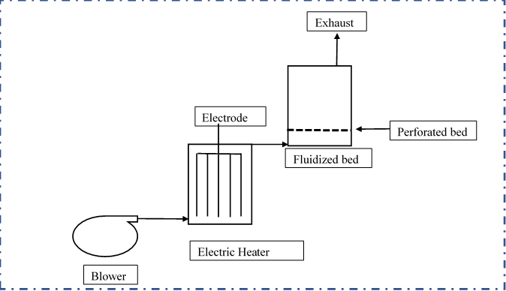

Figure 3.1: Sherwood Tornado 501 Dryer Representation Diagram

|  |  |  |
| --- | --- | --- |
|  | $$X= \frac{\left(W_{w }-W_{d}\right). W_{d} }{100}$$ | (29) |

## Design of experiment

Minitab software was used for design of experiment and analysis of experimental data. The Box Behnken design of the response surface methodology with 3 factors and two levels was used to design experimental models, analyze and optimize the drying process Table 3.1 shows levels and factors that were used in the experiment.

Table 3.1: Levels and Factors in the Experiment

|  |  |  |  |
| --- | --- | --- | --- |
| **Symbol** | **Intermediate variables** | **Actual levels uncoded factors** | |
| **Low** | **High** |
| AT | Air temperature (0C) | 70 | 130 |
| AV | Air Velocity (m/s) | 0.21 | 0.55 |
| Td | Drying Time (min) | 3 | 20 |
| d | Dhool | 1000 (g) and 4 cm height | |

### Experimental Models

Table 3.2 illustrates the experimental models that were developed from the response surface methodology.

Table 3.2: Design of Experiment

| **Std Order** | **Run Order** | **Blocks** | **Temperature** | **Velocity** | **Time** |
| --- | --- | --- | --- | --- | --- |
| 1 | 1 | 1 | 70 | 0.21 | 11.5 |
| 2 | 2 | 1 | 130 | 0.21 | 11.5 |
| 3 | 3 | 1 | 70 | 0.55 | 11.5 |
| 4 | 4 | 1 | 130 | 0.55 | 11.5 |
| 5 | 5 | 1 | 70 | 0.38 | 3 |
| 6 | 6 | 1 | 130 | 0.38 | 3 |
| 7 | 7 | 1 | 70 | 0.38 | 20 |
| 8 | 8 | 1 | 130 | 0.38 | 20 |
| 9 | 9 | 1 | 100 | 0.21 | 3 |
| 10 | 10 | 1 | 100 | 0.55 | 3 |
| 11 | 11 | 1 | 100 | 0.21 | 20 |
| 12 | 12 | 1 | 100 | 0.55 | 20 |
| 13 | 13 | 1 | 100 | 0.38 | 11.5 |
| 14 | 14 | 1 | 100 | 0.38 | 11.5 |
| 15 | 15 | 1 | 100 | 0.38 | 11.5 |

## Design analysis

The study and analysis of fluidized bed dryer was done using ANSYS Fluent 2022/R1. ANSYS design modeler was used to develop the FBD geometry.

### Computational Fluid Dynamics

Start

Geometry

Meshing

Physics

Solver

Report

Post Process

End

* Shape drawing
* Domain shape and size
* Meshing determination
* Boundary designation
* Setup of model
* Setup of material
* Determination of boundary conditions
* Solution methods
* Solution controls
* Initialization
* Plots
* Amination
* Contour

Figure 3.2: Computational Fluid Dynamics Simulation Process

### CFD Modeling

ANSYS Fluent software was used to conduct fluid dynamic simulation. Simplification of the real FBD dryer was done using 2D geometry. For fluid dynamics modelling to be performed through CFD simulation, some key steps were highlighted. These included: (i) 2D geometry development (ii) Geometry meshing (iii) Defining boundary conditions. (iv) Simulation setup and results reading. (v) Validation of the results. Below are the assumptions were used for process simplification in CFD simulation.

1. Stationary FBD simulation.
2. Fluidization air is incompressible and with constant density.
3. No heat loses to ambient.
4. Outside dryer conditions at normal atmospheric pressure 101325 Pa.
5. Hot air inlet velocity is 0.38 m/s.
6. Fluid flow is turbulent
7. Chemical reactions, thermal behaviour and moisture loss were not studied.
8. Dryer fluidization air considered with no particle concentration (Perez Cortes et al., 2021).

### Geometry and Meshing

The real plant dryer front view was developed in 2D geometry using ANSYS deign modeler. The 2D geometry model is shown in Figure 3.3 while Figure 3.4 shows the geometry mesh. The model was then meshed using a tetrahedral type element. The geometry meshing was generated using the element size of 0.05 m. This resulted in 11420 nodes and 11400 elements. Patch conforming method in ANSYS was used for meshing.

Outlet

Fluid domain

7 M

4 M

Wall

Inlet

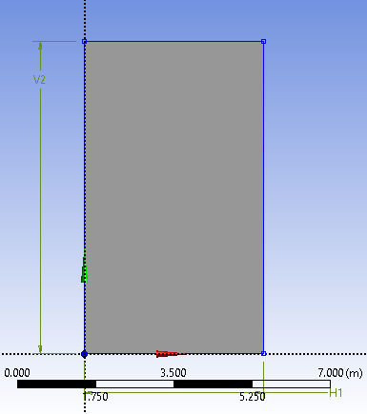

Figure 3.3: 2D Dimensional FBD Geometry

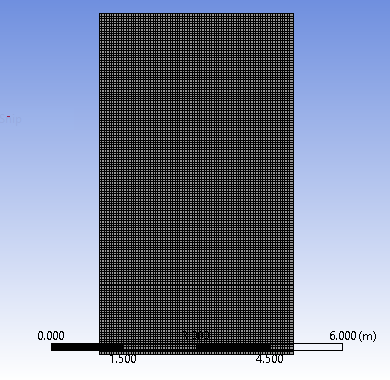

Figure 3.4: Mesh Structure of the Model FBD

Table 3.3: ANSYS Meshing

|  |  |  |  |
| --- | --- | --- | --- |
| **Details** | **Options** | | |
| ANSYS default setting | Physics |  | CFD |
| Solver |  | Fluent |
| Element size |  | 0.05 |
| Element order |  | Linear |
| Export format |  | Standard |
| Sizing | Adaptive sizing (No) | Growth rate | 1.2 |
| Mesh defeaturing (yes) | Defeature size | 2.5 e-005 m |
| Capture curvature (yes) | Curvature min size  Curvature normal angle | 5.e-005 m  18.00 |
| Capture proximity |  | No |
| Face sizing | Scope | Scope method | Geometry choice |
| Inflation | Scope  Definition | Scope method  Suppressed  Boundary scoping method | Geometry selection  No  Geometry selection |

#### Mesh Independency Test

The model outlet air velocity was singled out as the parameter for mesh independency test analysis. Table 3.4 illustrates three different mesh criteria developed from the ANSYS software to simulate tea drying process. The experiment gave 0.38 m/s as exit air velocity and this was used to study simulation meshing. The mesh element size of 30,989 gave a simulation result of 0.41 m/s with a percentage error of 7.89 %. The mesh element size of 44,800 gave a simulation result of 0.40 m/s with a percentage error of 5.88 %. The final mesh size of 70,000, produced simulation velocity of 0.39 m/s with a percentage error of 2.63 %. The element sizes of 44, 800 and 70,000 gave reduced error margins. For the sake of shorter computational time in ANSYS fluent, element size of 44,800 was considered for simulation.

Table 3.4: Mesh Independency Review

|  |  |  |  |  |  |
| --- | --- | --- | --- | --- | --- |
|  | **Mesh count** | | **Experimental outletvelocity (m/s)** | **Simulation outlet air velocity (m/s)** | **Percentage error (%)** |
| 1 | Elements | 30989 | 0.38 | 0.41 | 7.89 |
| Nodes | 31356 |
| 2 | Elements | 44 800 | 0.38 | 0.40 | 5.26 |
| Nodes | 45 241 |
| 3 | Elements | 70000 | 0.38 | 0.39 | 2.63 |
| Nodes | 70551 |

### Boundary Conditions and Simulation Setup

Suitable boundary conditions were set on the fluid computational area in order to achieve computational results with minimal error. FBD inlet boundary condition at the bottom was set as inlet velocity whereas the outer boundary condition for the FBD at the top was set at the default pressure outlet. The model wall condition was set as no-slip and this applied to both solid and gas phases. The standard wall function in near wall modelling accommodated the effects of higher viscosity and higher velocity gradients. Table 3.5 shows the model boundary conditions while Table 3.6 shows the ANSYS solver setup conditions.

Table 3.5: Model Boundary Conditions

|  |  |
| --- | --- |
| **Mode** | **Description** |
| Primary phase | Hot air, 373.15K  Density, 1.205 kg/m3  Viscosity (0.21 m/s) |
| Secondary phase | Dhool (particle)  Density (480 kg/m3)  Dhool size (3000 micrometre) |
| Mesh type | Tetrahedral |
| Inlet air temperature | 373.15K |
| Inlet velocity - Air | 0.21 m/s |
| Outlet temperature - Air |  |
| step size - Time | 0.1 sec |
| Number of time steps | 500 |

Table 3.6: ANSYS Solver Setup Conditions

| **Mode** | **Description** | | |
| --- | --- | --- | --- |
| General | Solver | Type  Time | Pressure based  Transient |
| Gravity |  | -9.81 m/s |
| Model | Multiphase Eulerian | Phases | Phase 1 – Air  Phase 2 – particle |
|  | Particle size | 3000 micrometre |
| Viscous | K - Epsilon | Realizable |
|  | Near wall treatment | Scalable wall function |
| Phase interaction |  | Syamlal O. Brian |
| Material | Fluid  Mixture |  | Air  Dhool and air |
| Boundary condition | Inlet |  | Air velocity – 0.38 m/s. |
| Air temperature –373.15K |
| Pressure – 101325 Pa |
| Solution | Method | Scheme | Second order |
| Initialization |  | Hybrid |

### Fluidization Condition

A 2D FBD model was used to analyse the dhool fluidization process. Dhool volume fraction was patched at 0.6 as seen in Figure 3.5 The patched distance was 4m along the X axis and 0.5m along the Y axis covering 2400 cells. Hot air cushion holding the particulate at a height is at minimum fluidization. The minimum velocity was calculated based on Equation 30.

$v_{mf}=\frac{\left(φd_{p }\right)2}{150μ} \left\{g\left(pc-pg\right)\right\}. \frac{{ε_{mf}}^{3}}{1-ε_{mf}}$ (Yohana, E., Nugraha 2018) (30)

Where:

Φ= Sphericity

ρ = Density

µ = Viscousity

g = gravity

Wen and Yu equation explains the correlation between the porosity at minimum fluidization and sphericity

$φ x ε_{mf}= \frac{1}{14}$ (31)



Figure 3.5: Dhool Bed Height Patching

CHAPTER FOUR

RESULTS AND DISCUSSION

# Results and Discussion

## 4.1 Drying Experimental Results

Table 4.1 shows the moisture content at various drying times.

Table 4.1: Moisture Content at Various Drying Times

|  |  |
| --- | --- |
| **Time (mins)** | **Moisture Content (kg H2 O / kg DM)** |
| 0 | 72 |
| 3 | 32 |
| 5 | 21 |
| 8 | 15 |
| 10 | 11 |
| 13 | 9 |
| 15 | 7 |
| 17 | 5 |
| 20 | 3.5 |

### Drying Curve

Figure 4.1 illustrates the moisture content reduction profile verses tea drying time. The initial moisture content of the fermented macerated tea was 72 % wb. The moisture content and dhool weight of fermented tea reduced with increased drying time in the FBD as hot air was blown through the bed. The final black tea moisture content was 3.5 % db after 20 minutes.

Figure 4.1: Relationship between Moisture Content and Drying Time

### Rate of Drying Curve

Figure 4.2 shows the rate of drying. It can be seen from Figure 4.2 that the highest rate of drying of about 13.5 kg H2O/min was achieved at a moisture content rate of between 32-72 kg H2O/kg DM. At a moisture content of less than 32 kg H2O/kg DM, the drying rate decreases up to about 6 kg H2O/kg DM after which it almost remains constant.

Figure 4.2: Relationship between Drying Rate and Moisture Content

## Results of Experimental Runs

The experimental models were evaluated and the resultant moisture content of each model is indicated in Table 4.2. The lowest moisture content reduction (68 kg H2O/kg DM) occurred at a temperature, time and velocity of 70 °C, 3 minutes and 0.38 m/s respectively. At a temperature, time and velocity of 130 °C, 20 minutes and 0.38 m/s a moisture content of 4 kg H2O/kg DM was obtained.

Table 4.2: Resultant Moisture Content at Different Drying Conditions

| **Std Order** | **Run Order** | **Blocks** | **Temperature °C** | **Velocity (m/s)** | **Time (mins)** | **Moisture (db)** |
| --- | --- | --- | --- | --- | --- | --- |
| 1 | 1 | 1 | 70 | 0.21 | 11.5 | 55 |
| 2 | 2 | 1 | 130 | 0.21 | 11.5 | 32 |
| 3 | 3 | 1 | 70 | 0.55 | 11.5 | 25 |
| 4 | 4 | 1 | 130 | 0.55 | 11.5 | 15 |
| 5 | 5 | 1 | 70 | 0.38 | 3 | 68 |
| 6 | 6 | 1 | 130 | 0.38 | 3 | 21 |
| 7 | 7 | 1 | 70 | 0.38 | 20 | 10 |
| 8 | 8 | 1 | 130 | 0.38 | 20 | 4 |
| 9 | 9 | 1 | 100 | 0.21 | 3 | 50 |
| 10 | 10 | 1 | 100 | 0.55 | 3 | 32 |
| 11 | 11 | 1 | 100 | 0.21 | 20 | 11 |
| 12 | 12 | 1 | 100 | 0.55 | 20 | 9 |
| 13 | 13 | 1 | 100 | 0.38 | 11.5 | 7 |
| 14 | 14 | 1 | 100 | 0.38 | 11.5 | 3.5 |
| 15 | 15 | 1 | 100 | 0.38 | 11.5 | 8 |

## Model Summary

Table 4.3 shows the coefficient of determination summary for the model at the confidence level of 95 % or 5 % significance. The analysis resulted in R2, adjusted R2  and predicted R2 values of 96.98 %, 91.54 % and 54.35 % respectively. This confirms the significance and adequacy of the model. The R2 value of 96.98 %, implies that the model’s response which is the dhool moisture content can explain the tea drying variables of study.

Table 4.3: Summary of Statistical Parameters

|  |  |
| --- | --- |
| **Coefficient of determination** | **Value** |
| S | 5.88926 |
| R-square | 96.98 % |
| Adjusted R- squared | 91.54 % |
| Predicted R- Squared | 54.35 % |

### Analysis of Variance

Table 4.4 show the analysis of variance (ANOVA). The model at 95 % confidence level yieded F and P values of 17.87 and 0.003 respectively. This implies that the model is significant. From Table 4.4, it can be seen that all linear variables of study are significants since the P values in each case is less than 0.05.

Table 4.4: Analysis of Variance

| **Source** | **DF** | **Adj SS** | **Adj MS** | **F-Value** | **P-Value** |
| --- | --- | --- | --- | --- | --- |
| Model | 9 | 5567.82 | 618.65 | 17.84 | 0.003 |
| Linear | 3 | 3831.75 | 1277.25 | 36.83 | 0.001 |
| Air Temperature | 1 | 924.50 | 924.50 | 26.66 | 0.004 |
| Air velocity | 1 | 561.13 | 561.13 | 16.18 | 0.010 |
| Drying Time | 1 | 2346.12 | 2346.12 | 67.64 | 0.000 |
| Square | 3 | 1209.57 | 403.19 | 11.62 | 0.011 |
| Air Temperature*Air Temperature | 1 | 616.03 | 616.03 | 17.76 | 0.008 |
| Air velocity*Air velocity | 1 | 592.41 | 592.41 | 17.08 | 0.009 |
| Drying Time*Drying Time | 1 | 164.10 | 164.10 | 4.73 | 0.082 |
| 2-Way Interaction | 3 | 526.50 | 175.50 | 5.06 | 0.056 |
| Air Temperature*Air velocity | 1 | 42.25 | 42.25 | 1.22 | 0.320 |
| Air Temperature*Drying Time | 1 | 420.25 | 420.25 | 12.12 | 0.018 |
| Air velocity*Drying Time | 1 | 64.00 | 64.00 | 1.85 | 0.232 |
| Error | 5 | 173.42 | 34.68 |  |  |
| Lack-of-Fit | 3 | 162.25 | 54.08 | 9.69 | 0.095 |
| Pure Error | 2 | 11.17 | 5.58 |  |  |
| Total | 14 | 5741.23 |  |  |  |

### Regression Equation

Equation 32 shows the relationship between the moisture content and the three parameters of study.

|  |  |  |
| --- | --- | --- |
| **Moisture Content =** | 385.4 - 3.933 Air Temperature - 478 Air velocity - 9.21 Drying Time + 0.01435 Air Temperature*Air Temperature + 438 Air velocity*Air velocity + 0.0923 Drying Time*Drying Time + 0.637 Air Temperature*Air velocity + 0.0402 Air Temperature*Drying Time + 2.77 Air velocity*Drying Time | (32) |

### Modified Regression Equation

Equation 32 was improved with elimination of non-significant parameters. The Equation 33 shows the improved regression equation with only significant variables in the study.

|  |  |  |
| --- | --- | --- |
| **Moisture Content =** | 385.4 - 3.933 Air Temperature - 478 Air velocity - 9.21 Drying Time + 0.01435 Air Temperature*Air Temperature + 438 Air velocity*Air velocity + 0.0402 Air Temperature*Drying Time | (33) |

## Optimization of Process Variables

The response optimizer under RSM was used to optimize the black tea drying process parameters. Figure 4.3 shows the optimal drying process variables. As seen in Figure 4.3, the optimal process variables values of 100 °C air temperature, 0.38 m/s drying air velocity/s and 12.9 minutes dhool drying time were obtained. The resultant moisture content of black tea was 3.5 kg H2O/ kg DM.

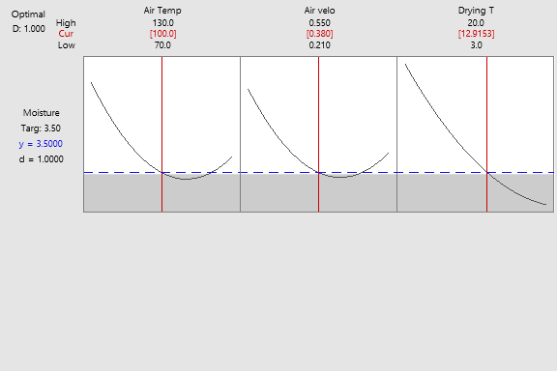

Figure 4.3: Optimal Drying Process Variables

## Surface and Contour Plots

Figure 4.4 shows the surface plot of moisture content versus temperature and velocity of drying air at a constant drying time of 12.9 minutes. From Figure 4.4, it can be seen that the dhool moisture content level decreases with increase in both drying air velocity and temperature.

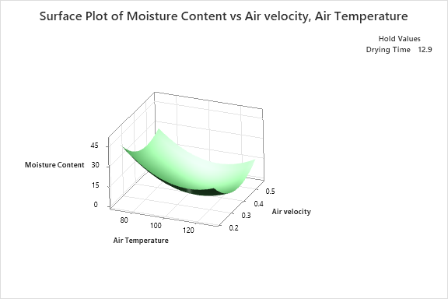

Figure 4.4: Surface Plot of Moisture Content vs Velocity and Temperature

Figure 4.5 shows the contour plot of dhool moisture content against drying air velocity and temperature at a constant drying time of 12.9 minutes. Air temperatures between 88 °C-130 °C and velocities between 0.3 m/s -0.55 m/s yielded a moisture content of below 10 kg H2O / kg DM. The most acceptable moisture content falls within this region. This confirms that the optimal drying variables of 100 °C air temperature and 0.38 m/s air velocity fall within the region.

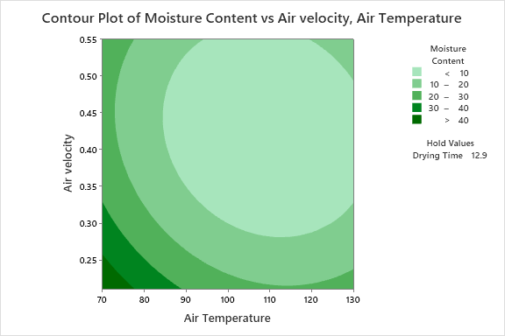

Figure 4.5: Contour Plot of Moisture Content vs Velocity and Temperature

## Energy and Exergy Analysis

Table 4.5 shows the input and output temperatures at different times.

Table 4.5: Input and Output Temperatures

|  |  |  |  |  |
| --- | --- | --- | --- | --- |
| **Drying air temperature in (**°C**)** | **Drying air temperature out (**°C**) at different drying times** | | | |
| 4 mins | 8 mins | 10 mins | 13 mins |
| 90 | 72 | 79 | 84 | 85 |
| 95 | 70 | 79 | 84 | 92 |
| 100 | 68 | 74 | 87 | 96 |

### Energy Analysis

Drying being an energy intense process, energy analysis was vital in this research work. At 90 °C dryer infeed air temperature with dryer exhaust air temperatures of 72 °C, 79 °C, 84 °C and 85 °C, the energy utilization of 14.224 MJ/kg, 8.858 MJ/kg, 4.741 MJ/kg and 3.95 MJ/kg respectively was achieved for drying times of 4, 8, 10 and 13 minutes. At a temperature of 95 °C, energy utilization values of 19.754 MJ/kg, 12.643 MJ/kg, 8.692 MJ/kg and 2.37 MJ/kg were achieved. At 100 °C infeed air temperature, energy utilization values of 25.286 MJ/kg, 20.545 MJ/kg, 10.272 MJ/kg and 3.161 MJ/kg were achieved. The results of energy utilization are presented in Table 4.6.

Table 4.6: Results on Energy Utilization

|  |  |  |  |  |
| --- | --- | --- | --- | --- |
| **Experiment No.** | **Velocity (m/s)** | **Temperature (oC)** | **Dhool (g)** | **Moisture**  **(db)** |
| 1 | 0.3 | 90 | 1250 | 3.3 |
| 2 | 0.38 | 90 | 1250 | 3.4 |
| 3 | 0.3 | 100 | 1250 | 3.2 |
| 4 | 0.38 | 100 | 1250 | 3.3 |
| 5 | 0.3 | 95 | 1000 | 3.5 |
| 6 | 0.38 | 95 | 1000 | 3.3 |
| 7 | 0.3 | 95 | 1500 | 3.5 |
| 8 | 0.38 | 95 | 1500 | 3.4 |
| 9 | 0.34 | 90 | 1000 | 3.4 |
| 10 | 0.34 | 100 | 1000 | 3.4 |
| 11 | 0.34 | 90 | 1500 | 3.5 |
| 12 | 0.34 | 100 | 1500 | 3.4 |
| 13 | 0.34 | 95 | 1250 | 3.5 |
| 14 | 0.34 | 95 | 1250 | 3.5 |
| 15 | 0.34 | 95 | 1250 | 3.6 |

Figure 4.6 shows the variation of dryer’s energy utilization (EU) as a function of drying time. It was observed that energy utilization reduced with increase in drying time. This trend explains skewed energy utilization at the start of drying process in a fluidized bed dryer when dhool had higher moisture content. As moisture is being evaporated from the dhool, energy utilization ration reduces.

Figure 4.6: Relationship Between Energy Utilization and Drying time

Figure 4.7 shows the variation in average energy utilization with drying temperature. It can be seen that the energy utilization of the dryer increases with increase in drying air temperature. The drying temperatures of 90 °C, 95 °C and 100 °C gave an average energy utilization of 7.9 MJ, 10.9 MJ and 10.8 MJ respectively.

Figure 4.7: Effect of Energy Utilization at Different Temperature Ranges

Figure 4.8 shows EUR in the FBD as a function of drying time. It can be seen that the energy utilization ratio decreases with prolonged drying time. The maximum energy utilization ratio of 0.44 MJ was observed at 100 °C after 4 minutes of dhool drying while the minimum energy utilization ratio of 0.045 MJ was noted at 95 °C after 13 minutes of drying.

Figure 4.8: Variation of Energy Utilization Ratio with Drying Time

Figure 4.9 exemplifies the average energy utilization ratio against drying temperature. It was observed that energy utilization ratio increased with increase in drying air temperature. The average energy utilization ratio of 0.2, 0.21 and 0.26 were recorded at 90 °C, 95 °C and 100 °C respectively.

Figure 4.9: Variation of Energy Utilization Ratio with Air Temperature

### Exergy Analysis

Figure 4.10 demonstrates the calculated exergy inflow to the fluidized bed dryer. Exergy values of 4.443 KJ/kg, 5.139 KJ/kg and 5.88 KJ/kg were obtained at temperatures of 90 °C °C, 95 °C and 100 °C respectively. From Figure 4.10, it is seen that an increase in air temperature results in an increase of exergy inflow.

Figure 4.10: Variation of Exergy Inflow with Temperature

Figure 4.11 shows the relationship between exergy utilization and drying time. High exergy utilization was observed during the early stages of drying. Exergy utilization decreases with increase in drying time due to decrease in dhool’s moisture content.

Figure 4.11: Variation of Exergy Utilization with Drying Time

Figure 4.12 expresses the relation of exergy loss as a function of time. The maximum exergy outflow of 5.28 MJ/kg is seen at 100 °C whereas the minimum exergy outflow of 1.93 MJ/kg was observed at 100 °C. Exergy outflow increases with increase in drying time.

Figure 4.12: Variation of Exergy at the outlet with Drying Time

Figure 4.13 illustrates the variation of exergy efficiency against drying time. The maximum exergy efficiency of 67.18 % was observed at100 °C. However, the minimum exergy efficiency of 8.23 % was noted at 95 °C. It was observed that the exergy efficiency of the dryer was higher at the beginning of the drying process and reduced with drying time. This explains that at the commencement of the drying process, a lot of energy is used for water removal from dhool leading to high exergy efficiency. As the drying process continues, with some energy supply, less water will be available for evaporation hence less energy usage resulting to less exergy efficiency.

Figure 4.13: Variation of Exergy Efficiency with Drying Time

## Simulation results

This section presents the results inside the fluidized bed dryer regarding three variables of study i.e. air velocity, temperature and drying time.

### Dhool Fluidization Analysis

The inlet drying air temperature was 373.15 K. The drying simulation was conducted from zero seconds. The contours of volume fraction were considered for this analysis at different fluidization times and velocities. Figure 4.14 shows the volume fraction at the beginning of the simulation. Dhool is set at the lowest surface of the dryer bed. At this stage, drying air has not been introduced.

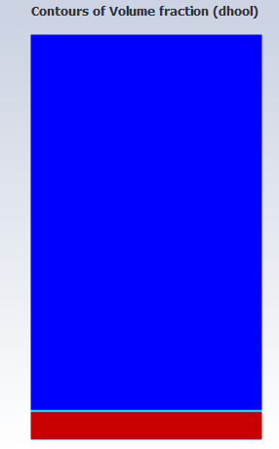

Figure 4.14: Initial Volume Fraction of Dhool

Figure 4.15 shows the volume fraction of contours at 2 seconds while Figure 4.16 shows the volume fraction contours at 10 seconds. The phenomena continues until the bed becomes more turbulent as seen in Figure 4.16.

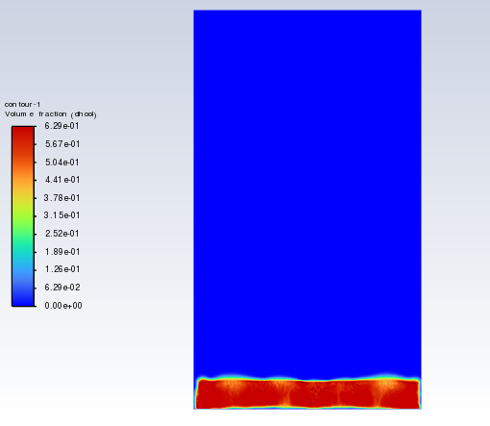

Figure 4.15: Volume Fraction of Dhool at 2 seconds

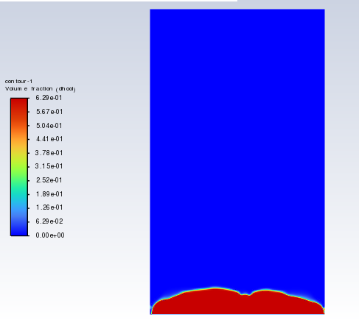

Figure 4.16: Volume Fraction of Dhool at 10 seconds

### Drying Air Velocity Analysis

The velocity contour at fluidization stage is shown in Figure 4.17 Air velocity analysis inside the fluidized bed dryer was varied at a minimum and maximum fluidization velocities of 0.21 m/s and 3.2 m/s respectively. The inlet air was considered constant at a temperature of 100 °C. High velocity is observed near the dryer wall. This is attributed to porous jump pressure due to bed perforation

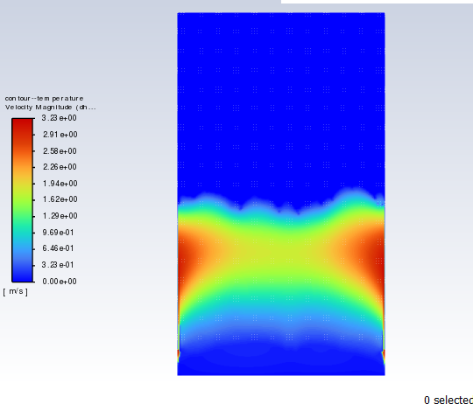

Figure 4.17: Velocity Contour at Fluidization Stage

CHAPTER FIVE

CONCLUSIONS AND RECOMMENDATIONS

# Conclusions and Recommendation

## Conclusion

The experimental analysis of tea drying resulted in a dynamic equilibrium moisture content of 3.5 kg H2O/ kg DM which was attained after 20 minutes of drying time. The optimal drying variable obtained were drying air velocity of 0.38 m/s, drying air temperature of 100 °C and drying time of 12.9 minutes with energy utilization of 14.2 MJ/kg. It was observed that higher energy utilization was achieved during constant rate period of the drying phase. Decreased energy utilization was seen during the falling rate. Increase in drying air temperature also increased energy utilization ratio. The exergy outflow increased with prolonged drying time. Increase in drying air temperature resulted in increased energy utilization and energy utilization ratio.

## Recommendation

The results from this study will be helpful in optimizing tea industry fluidized bed dryers as well as in future design and production of dryers. There is need to conduct further studies on dhool pre-treatment prior to the drying process with the intention of reducing the dryer energy consumption without compromising tea the quality of leaves. Due to the possibility of some energy being lost through the dryer exhaust, there is need to explore ways of maximizing the use of energy and exergy in the FBD. This could be achieved through introduction of a mixing chamber to help feed back the hot air into the dryer.

REFERENCES

Ananda, A. D. (2009). Aktivitas antioksidan dan karakteristik organoleptik minuman fungsional teh hijau (Camellia sinensis) rempah instan.

Antony, J., and Shyamkumar, M. (2016). Study on sand particles drying in a fluidized bed dryer using CFD. *International Journal of Engineering Studies*, *8*(2), 129-145.

Białobrzewski, I., Zielińska, M., Mujumdar, A. S., and Markowski, M. (2008). Heat and mass transfer during drying of a bed of shrinking particles–Simulation for carrot cubes dried in a spout-fluidized-bed drier. *International Journal of Heat and Mass Transfer*, *51*(19-20), 4704-4716.

Cheevitsopon, E., and Noomhorm, A. (2011). Effects of parboiling and fluidized bed drying on the physicochemical properties of germinated brown rice. *International journal of food science and technology*, *46*(12), 2498-2504.

Chowdhury, M., Bala, B., and Haque, M. (2011). Energy and exergy analysis of the solar drying of jackfruit leather. *Biosystems Engineering*, *110*(2), 222-229.

Das, H. J., Mahanta, P., Saikia, R., and Tamuly, P. (2021). Thermodynamic analysis in bubbling fluidized bed dryers with spiral and cone angles. *Journal of Thermal Science and Engineering Applications*, *13*(6), 061019.

Deb, S., and Jolvis Pou, K. (2016). A review of withering in the processing of black tea. *Journal of Biosystems Engineering*, *41*(4), 365-372.

Izadifar, M., and Mowla, D. (2003). Simulation of a cross-flow continuous fluidized bed dryer for paddy rice. *Journal of Food Engineering*, *58*(4), 325-329.

Jafari, A., Zamankhan, P., Mousavi, S., and Pietarinen, K. (2008). Modeling and CFD simulation of flow behavior and dispersivity through randomly packed bed reactors. *Chemical Engineering Journal*, *144*(3), 476-482.

Jamaleddine, T. J., and Ray, M. B. (2010). Application of computational fluid dynamics for simulation of drying processes: A review. *Drying Technology*, *28*(2), 120-154.

Kaleta, A., Górnicki, K., Winiczenko, R., and Chojnacka, A. (2013). Evaluation of drying models of apple (var. Ligol) dried in a fluidized bed dryer. *Energy Conversion and Management*, *67*, 179-185.

Kaya, A., Aydın, O., and Demirtaş, C. (2009). Experimental and theoretical analysis of drying carrots. *Desalination*, *237*(1-3), 285-295.

Kuriakose, R., and Anandharamakrishnan, C. (2010). Computational fluid dynamics (CFD) applications in spray drying of food products. *Trends in Food Science and Technology*, *21*(8), 383-398.

Lang’at, N. K. e., Thoruwa, T., Abraham, J., and Wanyoko, J. (2016). Performance of an iImproved fluidized system for processing green tea. *Int J Mech Aerospace Ind Mech Manuf Eng*, *10*, 1121-1126.

Meziane, S. (2011). Drying kinetics of olive pomace in a fluidized bed dryer. *Energy Conversion and Management*, *52*(3), 1644-1649.

Mousavi, S., Jafari, A., Chegini, S., and Turunen, I. (2009). CFD simulation of mass transfer and flow behaviour around a single particle in bioleaching process. *Process Biochemistry*, *44*(7), 696-703.

Mu’im Abdul Nasira, A., Roslia, M. I., Takriffa, M. S., Othmana, N. T. A., and Ravichandarb, V. (2021). Computational Fluid Dynamics Simulation of Fluidized Bed Dryer for Sago Pith Waste Drying Process. *Jurnal Kejuruteraan*, *33*(2), 239-248.

Mugi, V. R., and Chandramohan, V. (2021). Energy, exergy and economic analysis of an indirect type solar dryer using green chilli: A comparative assessment of forced and natural convection. *Thermal Science and Engineering Progress*, *24*, 100950.

Mujumdar, A. S. (2006). *Handbook of industrial drying*. CRC press.

Nazghelichi, T., Jafari, A., Kianmehr, M. H., and Aghbashlo, M. (2013). CFD simulation and optimization of factors affecting the performance of a fluidized bed dryer.

Perez Cortes, S. A., Aguilera Carvajal, Y. R., Vargas Norambuena, J. P., Norambuena Vasquez, J. A., Jarufe Troncoso, J. A., Hurtado Cruz, J. P., Munoz Lagos, A. P., and Jara Munoz, P. P. (2021). Modeling a fluidized bed dryer through computational fluid dynamics and the discrete element method. *Chemical Engineering and Technology*, *44*(9), 1567-1577.

Ramachandran, R. P., Akbarzadeh, M., Paliwal, J., and Cenkowski, S. (2018). Computational fluid dynamics in drying process modelling—a technical review. *Food and bioprocess technology*, *11*, 271-292.

Rosen, M. A., and Dincer, I. (1997). On exergy and environmental impact. *International Journal of Energy Research*, *21*(7), 643-654.

Sae-Heng, S., Swasdisevi, T., and Amornkitbamrung, M. (2011). Investigation of temperature distribution and heat transfer in fluidized bed using a combined CFD-DEM model. *Drying Technology*, *29*(6), 697-708.

Sarker, M. S. H., Ibrahim, M. N., Aziz, N. A., and Punan, M. S. (2015). Energy and exergy analysis of industrial fluidized bed drying of paddy. *Energy*, *84*, 131-138.

Smith, P. G. (2008). *Applications of fluidization to food processing*. John Wiley and Sons.

Sumnu, G., Turabi, E., and Oztop, M. (2005). Drying of carrots in microwave and halogen lamp–microwave combination ovens. *LWT-Food Science and Technology*, *38*(5), 549-553.

Syahrul, S., Hamdullahpur, F., and Dincer, I. (2002). Exergy analysis of fluidized bed drying of moist particles. *Exergy, an International Journal*, *2*(2), 87-98.

Taskinen, P., Jokilaakso, A., Lindberg, D., and Xia, J. (2020). Modelling copper smelting–the flash smelting plant, process and equipment. *Mineral Processing and Extractive Metallurgy*, *129*(2), 207-220.

Towaha, J. (2013). Kandungan senyawa kimia pada daun teh (Camellia sinensis). *Warta penelitian dan pengembangan tanaman industri*, *19*(3), 12-16.

Vera, I., and Langlois, L. (2007). Energy indicators for sustainable development. *Energy*, *32*(6), 875-882.

Yohana, E., Nugraha, A. P., Diana, A. E., Mahawan, I., and Nugroho, S. (2018). CFD analysis to calculate the optimal air velocity in drying green tea process using fluidized bed dryer. E3S Web of Conferences,

APPENDICES

**Appendix 1: Sherwood 501 fluidized bed dryer**

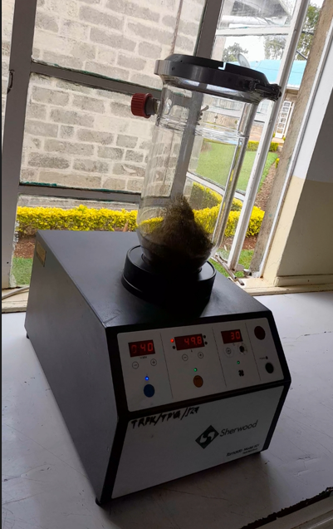

**Appendix 2: Kern EM weighing scale**

